Experiment no: 02
Experiment name: To Develop Sine and Cosine function wave-forms.
Theory: Linux enforces access control by categorizing users into Owner, Group, and Others. Each category may hold Read, Write, and Execute permissions, represented numerically as 4, 2, and 1 respectively. Read permits file viewing, Write allows content modification, and Execute enables script or program execution. The chmod command adjusts these settings, while shell scripting stores multiple commands in a file that requires execution rights to run.
Commands and Output:
- Chmod: Alters read, write, and execute privileges for files and directories through symbolic notation. Using u+x assigns execute access to the owner, g-w strips write privileges from the group, and o-r withdraws read access for other users.
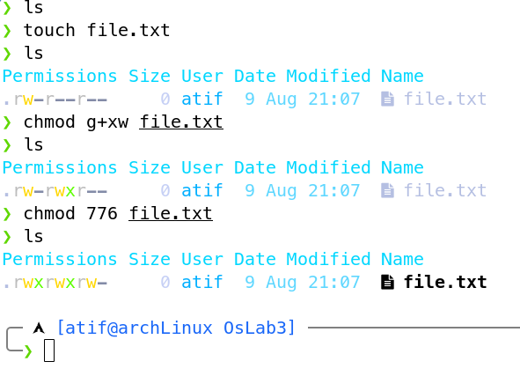

- Shell Scripting:
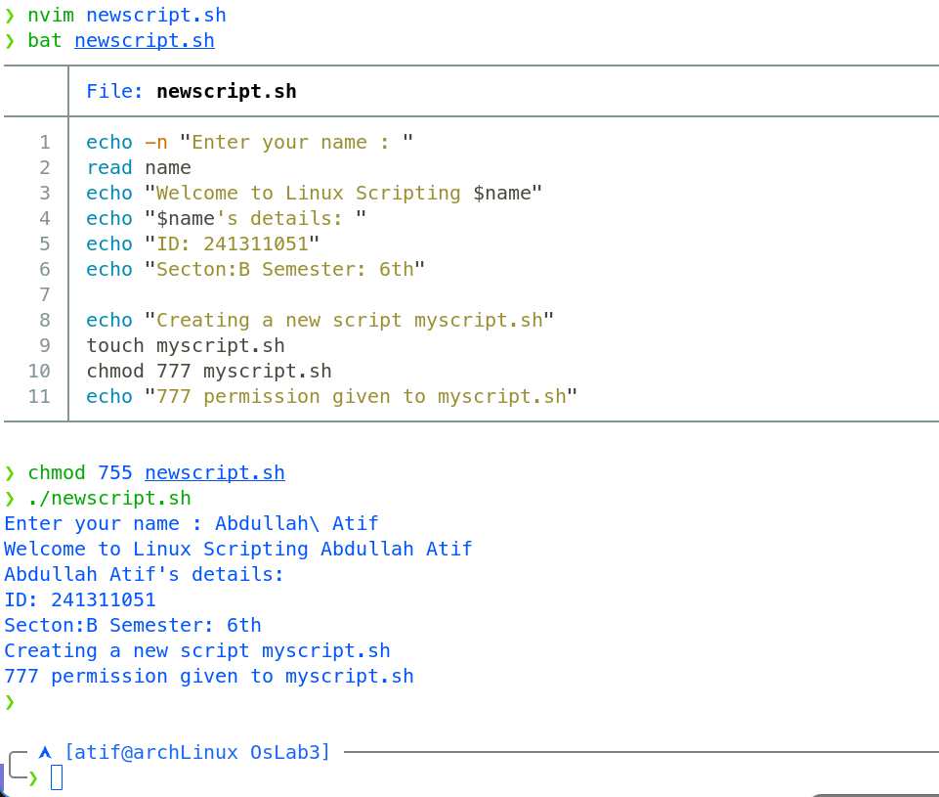

The script begins by prompting the user to enter their name and stores the input in a variable. It then displays a personalized welcome message followed by the user's academic details including ID, section, and semester. Next, it announces the creation of a new file named myscript.sh, generates it using the touch command, assigns full read, write, and execute permissions to all users via chmod 777, and finally prints a confirmation message indicating the permission change.
Discussion: This experiment demonstrated how Linux controls file access through permission management and shell scripting. Using chmod, we modified file privileges through both symbolic and numeric notations, understanding how Read, Write, and Execute permissions apply to Owner, Group, and Others. We also created a basic shell script that accepted user input, displayed personalized output, and automated file creation with permission assignment. These concepts are fundamental for secure multi-user environments and efficient task automation in Linux system administration.

